Amanda Bryant
MSc Urbanism, Delft University of Technology
abryant@student.tudelft.nl
www.linkedin.com/in/amandabryant
+31649522263
Barbarasteeg 2E19,
2611BM, Delft,
Zuid Holland, The Netherlands

The Redefinition of a Successful Suburb: A Comparative Study of Suburban Development Through the Case Studies of Amsterdam, Paris, and Vienna

Key Words:
Green Space, Social Interaction, Personalization, Accessibility, Orientation, Mixed Use, Mixed Housing, Suburb, Neighborhood, Development, Public Space, Identity

Abstract
The purpose of this paper was the investigation of the current criteria and ideas that support the redefinition and success of suburban development today. Through a series of case studies in the suburbs of the cities of Amsterdam, Paris, and Vienna, along with a series of interviews with academics and professionals criteria were concluded and organized into four topics of 1) The Use of Green Space, 2) Social Interaction and Personalization, 3) Accessibility and Orientation, and 4) Mixed Use and Mixed Housing. The neighborhoods visited were chosen based on their variety of urban approach, in particular the Garden Suburb and Modernist theories. Each of the suburbs were then compared to support and conclude the benefits of each criterion. The Use of Green Space is successful when utilized for both a view and interaction of inhabitants, while having a larger consideration for environmental impact. Social Interaction and Personalization is successful when the façade of the development allows for multiple levels of public space in order to invite activity, interaction, and identity of an area. Accessibility and Orientation is successful when multiple transportation options are provided and orientation is considered at multiple scales; both ensure inhabitants can successfully navigate the area. Lastly, Mixed Use and Mixed housing is successful when both are incorporated throughout a suburban development as a way to ensure diversity, flexibility and resilience of a neighborhood. These criteria have cumulative effects that support and promote the each of the other criteria. Together there is a new emphasis on the public space, accessibility, and identity in the redefinition of the success of suburban development today.
Introduction
When thinking of a suburb it is easy to picture a stereotypical development of a repetitive series of detached homes surrounded by personal gardens. But throughout the history of suburban development, there were challenges to this stereotypical idea, and today the definition of the suburb is being redefined entirely. A neighborhood is no longer just a neighborhood, but maintains an important interdependent relationship with the city. Therefore it is critical for planners to understand and redefine suburban development in order to support this relationship. Planners today are embracing the suburban idea as an integral part of city development, and working with expectations as a guide to adapt and meet the current needs and opportunities of the city. As cities reflect on the debate of suburban development, the formal developments that resulted in the past and present offer an interesting opportunity to understand the successes and failures of suburban development and answer the question: What are the current criteria and ideas for the redefinition of the success of suburban development today?
In this case study, three suburban neighborhoods were chosen within each of the cities of Amsterdam, Paris and Vienna. The neighborhoods were chosen based on the time of construction and varieties in their urban approach, in particular the Garden Suburb and Modern Suburb theories. The Garden City Movement, initiated by Ebenezer Howard, generated a new ideal of city development and from there the idea of the Garden Suburb emerged. The Garden Suburb centered on the idea of moving inhabitants away from inner cities, idolizing an escape of the city, and a natural environment experience. Garden Suburbs are characterized by detached or semi-detached houses surrounded by personal gardens located on a winding isolated street away from the existing city center. This movement streamlined suburban spread and its initial ideas were quickly adapted to different architectural styles. As the ideas of Modernism emerged, Modern suburban development challenged the use and function of the street and neighborhood by consolidating residences into high-rise structures, generating almost utopian lifestyle ideals, and utilizing public space only for a view. As a result, the vernacular of what it means to provide sufficient means of residence to inhabitants was formally challenged (Stern, 2013; Kostof, 1991). Including these theories establishes a larger understanding of how the ideas of a successful residential development have changed over time as well as offer a wider view into the understanding of what criteria supports and defines current successful suburban development.
Along with visiting each suburb, interviews conducted with academics and professionals offered further insight into the criteria that redefines a successful suburb today. The elements learned from site visits, along with the elements discussed in interviews were organized into four topics about contemporary suburban development: The Use of Green Space, Social Interaction and Personalization, Accessibility and Orientation, and Mixed Use and Mixed Housing. The observations made from site visits are compared to draw conclusions within each topic. The topics chosen have interactive cumulative effects that interact and react with each other, meaning that the achievement of one criterion is often based on the achievement of the others. Lastly, there are a variety of ways in which a criteria can be achieved or avoided formally, meaning that there is not one correct way to successfully develop a topic, but goals and intent that need to be addressed and considered.
Amsterdam
Geuzenveld-Slotermeer | The Dutch interpretation of the Garden City Suburb, the post war expansion neighborhood is characterized by row houses oriented around garden squares, and long apartment style building structures oriented parallel to each other (Verlag, 2014; Esteren, 1997; Dijkstra, 1999).
Betondorp | Meaning ‘concrete Village’, the Garden City inspired expansion incorporated the modern aesthetics of concrete into the traditional design of the neighborhood. Located in the eastern expansion of the city, the neighborhood is characterized by diagonal streets that lead to a central green space and other uses (Stern, 2013; Searing, 1987; Dijkstra, 1999).
IJburg | This development was built on a series of man-made islands in the IJsselmeer Lake of Amsterdam. The development is characterized by a central tramline, grid structure with a variety of interior blocks, smaller streets and public spaces, and consideration for the environment (Palmboom, 2015; Schot, 2001; Steenbergen, 2011).
Paris
HBM Housing 13th arr. | These neighborhoods, at the time of construction were at the edge of Paris, located on the space that was a defensive wall, and are located all around the city. These apartment style residences are seven stories high, and at a high density due to the housing shortage at the time of development (Evenson, 1979; Paneral, 2004).
The Tours Aillaud | This modern high-rise suburban development located in the western expansion of Paris, is characterized by cloud shaped towers, and small rounded windows. Additionally the landscape below is characterized by a synthetic landscape of small rolling hills and a giant mosaic snake sculpture (Forde, 2017; World, 2017; Paneral, 2004; Zandbelt, 2003).
Créteil | This suburban development, located in the southeast of Paris developed slowly and followed the metro line as it was extended. The suburb is characterized by a lack of a large-scale plan, and a variety of developments and housing types that reflects the changes in suburban theory (Créteil, 2012; Paneral, 2004).
Vienna
Flötzersteig | An English Garden inspired suburb developed for white-collar workers. This neighborhood is characterized by winding, sloping picturesque streets and traditional gardens and vernacular. Apartment style flats, typical of Vienna today, surround the neighborhood (Stern, 2013; Feuerstein, 1974; Hatz, 2008).
Werkbundsiedlung | Also English Garden suburb, this development maintains traditional elements with modern architectural elements. This suburb, like most other suburbs are located to the south of the city center (Stern, 2013; Feuerstein, 1974; Hatz, 2008).
Alt-Erlaa | A post-modern high-rise suburban development that combines residences into a series of concrete parabolic shaped towers. The development is characterized by the amenities provided within the buildings and first floor, the private green balconies provided on each floor, and the direct connection to the metro (Andel, 2016; Requat, 2017; Sarnitz, 2003).

Table 1 Suburbs Visited: The Table above offers a brief explanation into each of the suburbs visited in the cities of Amsterdam, Paris and Vienna.
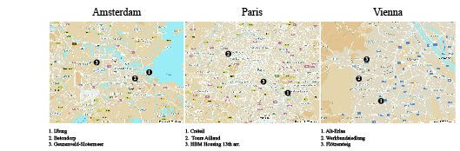

Figure 1 Suburb Map Diagram: The above diagram shows the location of each suburb in comparison to the city center.
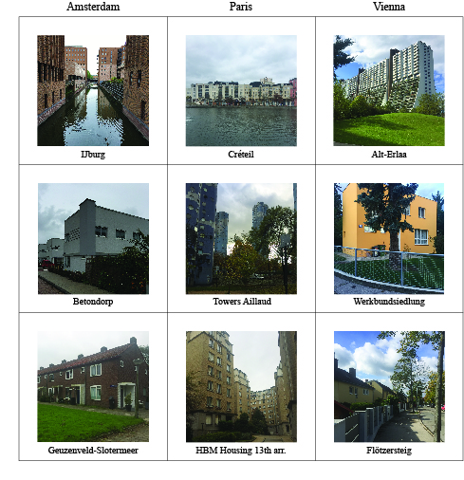
Figure 2 Suburbs Visited: The above figure shows an image from each suburb development visited in Amsterdam Paris and Vienna.
The Use of Green Space
The use and implementation of green space is key in suburban development. This influence goes back to the origin of the suburban idea in the Garden City movement where there was a desire to escape the city and become immersed in nature. Modernism countered these ideas utilizing green space as a view (Stern, 2013; Kostof, 1991). Today the implementation of green space is focused on the use at a pedestrian level, maintaining views and interaction at a higher density, and incorporating a larger consideration for the environment. Use at a pedestrian level requires maintaining green space on the street, in both functional and non-functional ways. Maintaining views and interaction at a higher density requires fulfilling the desire of a private garden within different housing typologies and densities. And maintaining a larger consideration for the environment requires implementing sustainable means of development in order to clean up or ensure protection of the natural area. Professionals and academics revealed how this is critical for development both for the people who will inhabit the area, and to reach the future environmental goals of the city. Inhabitants want the green space of a suburb, and planners are challenged with accommodating higher densities of people within cities, while maintaining the natural environment.
Take for example the suburbs of Betondorp and Werkbundsiedlung, although having modern aesthetics when compared to the suburbs of Geuzenveld-Slotermeer and Flötzersteig all of the suburbs maintained a traditional approach of implementing personal green space for each detached or semi-detached home through personal gardens. Geuzenveld-Slotermeer though, does attempt to provide shared green courtyards in between the orientation of row houses. For all of these suburban developments green space was implemented with both a personal view and interaction, but at a very low density. Additionally, because of the low density, the green space that accommodates the inhabitants also provides a view to pedestrians on the street, but does not have any additional function, and the environmental impact is not at all considered.
In contrast, The HBM housing of Paris reaches a higher density, as the apartment style buildings reach seven stories (Evenson, 1979), but does not implement green space or a view, apart from a few shrubs or trees. The port district of Créteil implements the shore of the water, creating a small public boulevard along the shore but this water was a man made adaptation of an old rock quarry (Créteil, 2012). Many of the other developments within Créteil maintain views to green space, and have small public courtyards. The Tours Aillaud provides the largest contrast in terms of the use of green space. The design followed the Modern ideal and utilized green space as a view but went a step further by creating its own synthetic altered landscape of cobblestone mounds scattered with trees. By altering the landscape the environment does not have a natural atmosphere and the continuous cobblestones minimize the opportunity for greenery. Additionally, it should be noted that the mounding landscape makes it difficult to have a clear view at a pedestrian level.
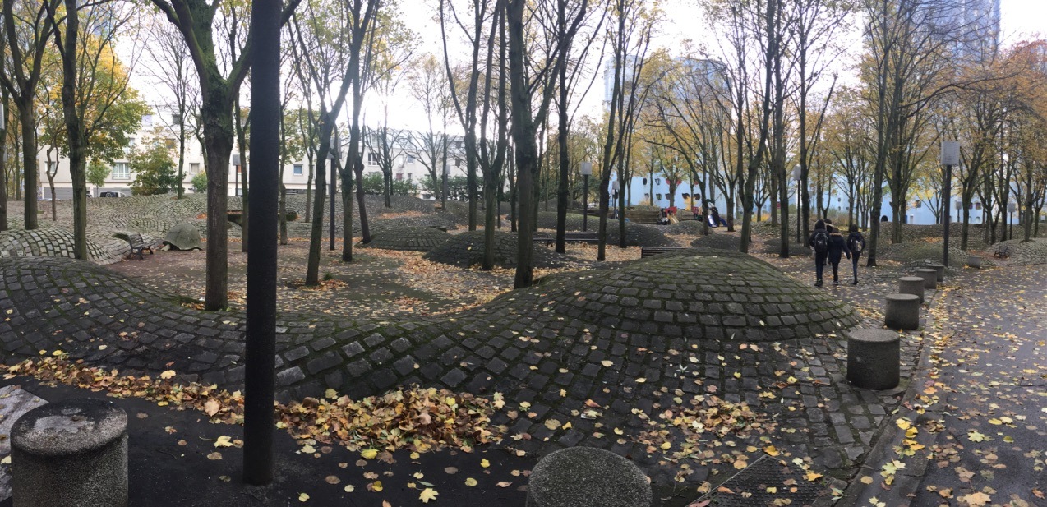
Figure 2 Tours Ailluad Green Space: View from the outdoor space below into the winding cobblestone mounds and trees.
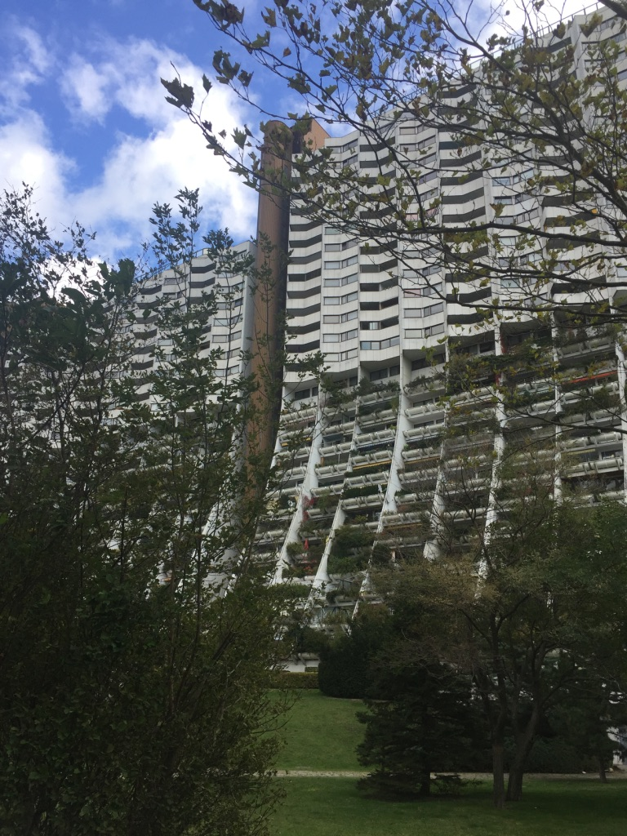
Alt-Erlaa, also Modern in its design, takes a very different approach and provides personal green space to the different apartments with a personal balcony capable of maintaining vegetation, while also providing a view to the park below and functional green spaces within the park. This combination achieves a high level of interaction with green space at a high density (Andel, 2016). Lastly, IJburg used green space as a public space component providing parks throughout the site, maximizing the view and interaction of the water for residents, and focusing on the ecosystem of the environment in the design of the area. In the development of IJburg, there was concern for the local wildlife as this neighborhood required the construction of a man made island within a lake. As a result, additional islands and wildlife reserves were added to the development to not only preserve the eco system, but also stimulate wildlife activity (Palmboom, 2015).
Figure 3 Alt-Erlaa Green Space: View from the interior park for residents looking into the private balconies.
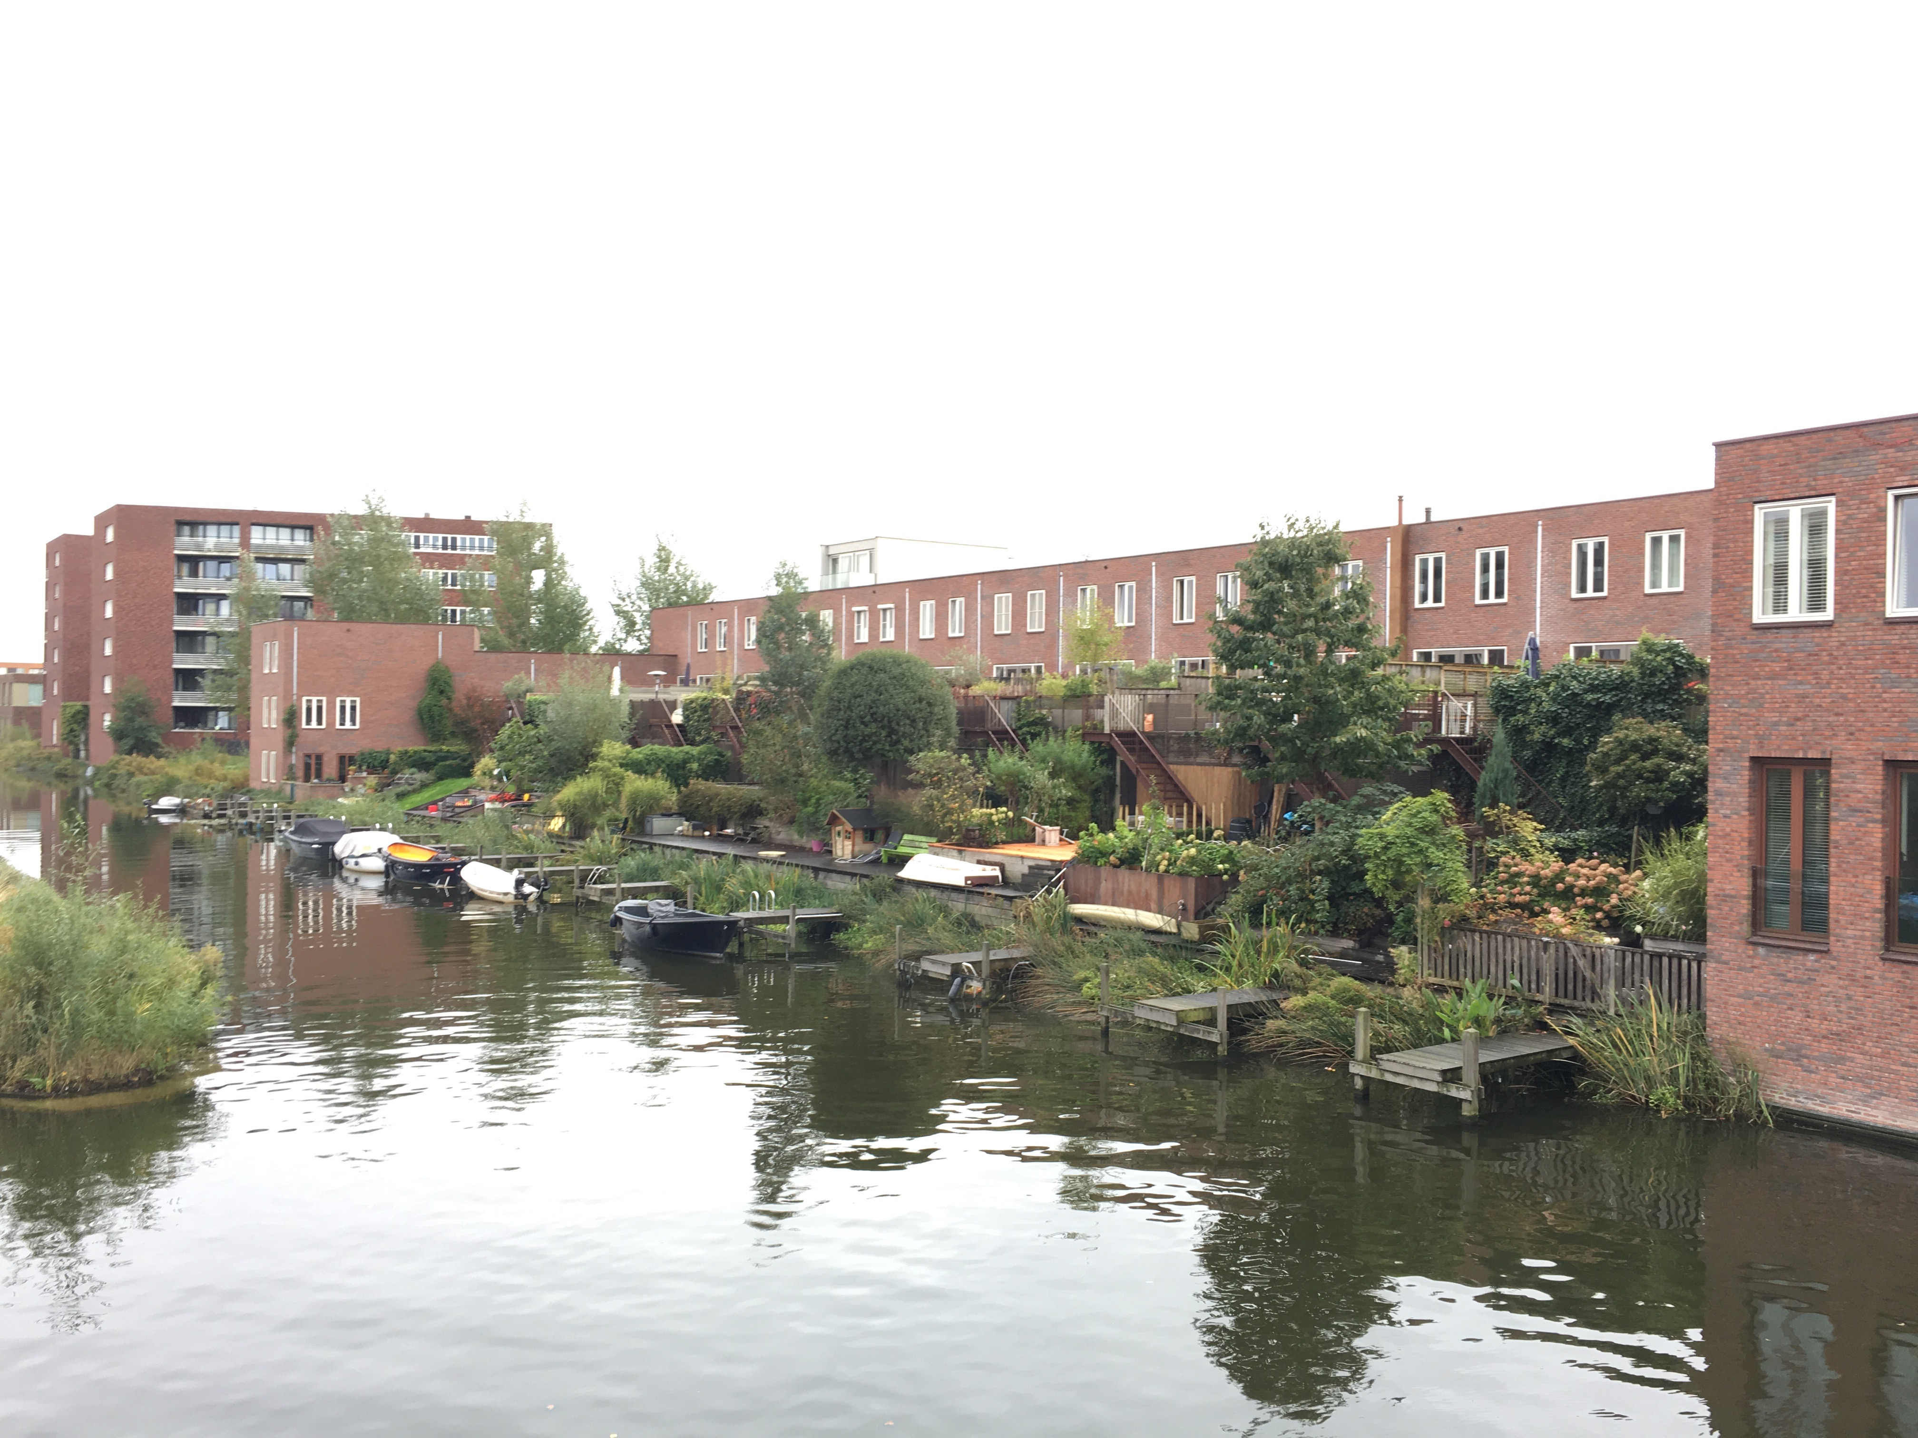
When comparing the different developments it becomes clear that there is a demand for maintaining a natural environment around a residence. Almost all developments attempt to directly incorporate green space as a view or through interaction. But what seems to be most successful is when the green space is both personal and shared, and natural and functional. The personal garden of a Garden Suburb single-family residence focused on the personal use of green space. This poses a challenge as it amounts to a very low density overall. The Modern high-rise suburbs in contrast, achieved high density, but only implemented a view of green space. The Tours Aillaud are an example of only using green space as a view, and this development in particular only minimizes the use of green space further by creating a rough synthetic landscape. Although Alt-Erlaa is Modern and high density it provides, in contrast, large amounts of green space with both a view and interaction. The personal balconies simulate the function that one would have of a private garden, while providing the view of a high-rise structure, and a functional shared green space below. IJburg, also successfully provides green space through both view and interaction, but with a different formal approach that allows for a larger consideration for the ecological environment, and a variety of interactions throughout the urban grid.
Figure 4 IJburg Green Space: View into the private garden and canals of one of a variety of green spaces in IJburg.
Social Interaction and Personalization
There is a new focus and responsibility to make a suburb function as a community and create opportunities for inhabitants to personalize and adapt to their surroundings. This critical component to suburban development was a hard lesson learned from the development and failure of Modernist style suburbs (Stern, 2013; Kostof, 1991). Social interaction and personalization are necessary for inhabitants to create an identity within their surroundings. This identity has the ability to generate and maintain the wellbeing of residents. Specifically there is an importance on the façade to provide opportunities of personalization, and generate different degrees of public and private space. These two elements build upon each other. A permeable façade, with elements such as a large window or a porch, allows for a resident to personalize their home, and indicates to people in the public space that the neighborhood is active. In addition the façade can create semi-public spaces that encourage inhabitants to participate in public space and creates opportunities for social interaction. Today, planners take a social responsibility to create these opportunities through both the large-scale plans, and human scale development guidelines.
The suburbs of Werkbundsiedlung, Geuzenveld-Slotermeer, Flötzersteig, Betondorp, and HBM Housing did not consider social interaction. The main goal was only to provide housing for residents. These traditional Garden Suburbs with detached and semi-detached houses with personal gardens easily allowed for personalization, but there is a clear division of space, and so minimal social interaction. Fences were often used to claim space as their own and further enforce minimal social interaction. The HBM housing, an apartment style suburb maintained a façade that provided minimal opportunities for personalization, in addition to having a clear division of public and private space. The suburb of Geuzenveld-Slotermeer, did attempt to promote social interaction through a shared green square in between houses, but homes often also maintained their own fenced in garden.
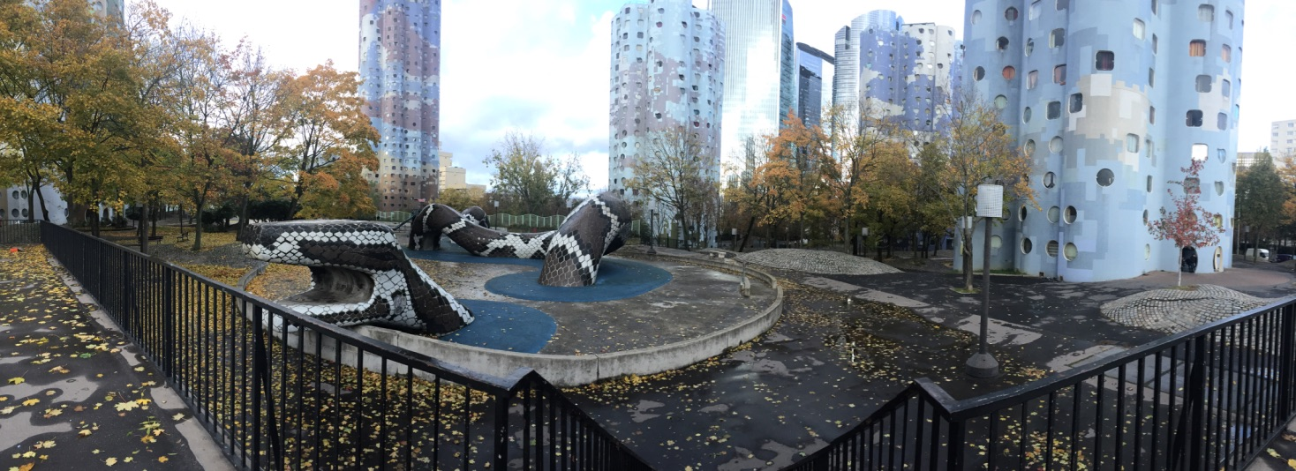
Figure 6 Tours Ailluad Social Interaction and Personalization: View into the public space of Tours Ailluad shows how the façade prevents personalization and view into the public space below. Additionally this figure also depicts the synthetic landscape discussed in the earlier section.

In stark contrast, the Tours Ailluad provides unsafe social interaction and no opportunities for personalization on the façade. Interaction between inhabitants is minimized, and from the exterior it is difficult to tell whether or not someone is home, or even lives in the apartment. The windows of the façade are small and round, and from within the high rise structure the view is isolated to other building windows, not to the public space below. The Les Choux de Créteil, by Gerard Grandval (Créteil, 2012), provides a safer alternative with the façade design that includes windows that view the street and personal balconies, which creates opportunities for personalization.
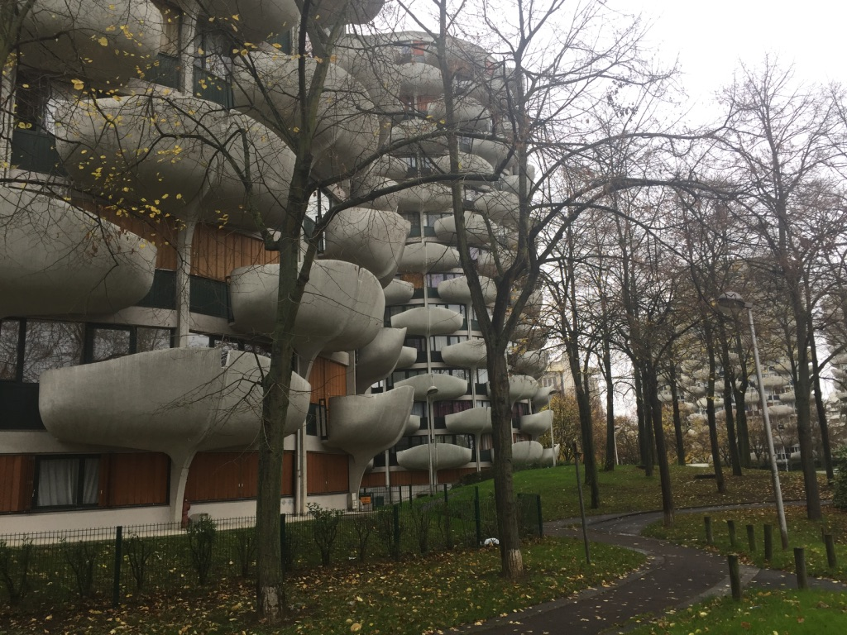
In contrast to this, although similar in design, Alt-Erlaa provides space for personalization through its balconies and social interaction through its extensive tenants network and associations. Tenants maintain a tenant association, have a personal newsletter, and even a connected landline phone that allows for phone calls between all residents (Andel, 2016). Lastly, IJburg provides social interaction and personalization through shared public spaces specific to each block. Upon development, architects and developers were asked to develop the interior of each block at a smaller scale with public and semi-public spaces. In order to provide and personalization to each home, IJburg maintained guidelines for implementing ‘margin strips’ at the ground floor of each entrance, for example plants, benches etc. This also created personalization and semi-public spaces (Palmboom, 2015).
Figure 6 Les Choux Social Interaction and Personalization: View in the public space looking onto the façade and balconies above.

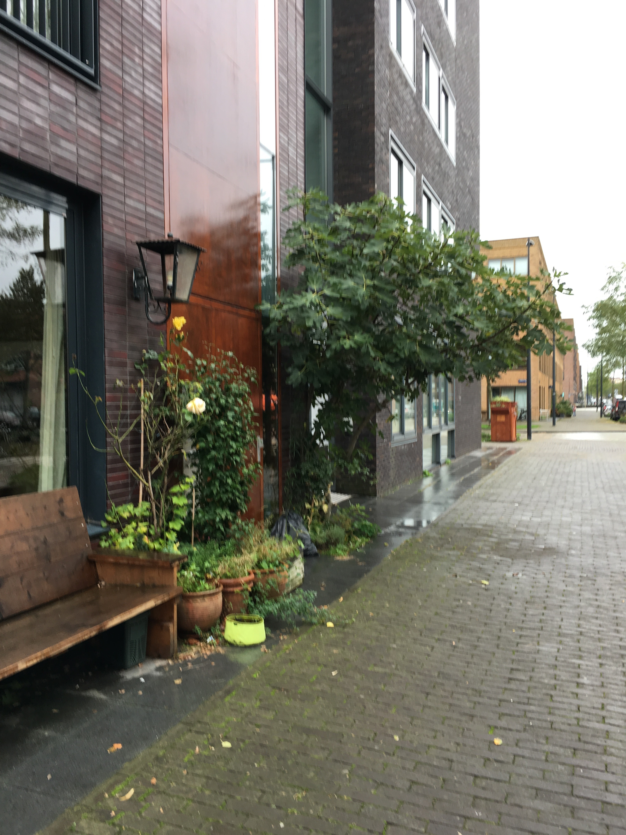
When comparing the different suburban developments, it becomes clear that there is success in developments that provide means of social interaction and personalization, and the façade of a development plays a critical role in this success. Almost all developments attempt to directly incorporate either social interaction or personalization. But what seems to be most successful is when personalization and social interaction work together to create a gradient of pubic spaces that invite attention and use of public space as well as generate an identity of the area. The façade is key for this interaction because it is the physical barrier between public and private space. It has the opportunity to allow for a view into public space, as well as create opportunities to participate in public space. Inhabitants in the public space reciprocate this view; they are able to view the personalization of homes from the street, which generates an identity and activity of the area. The Tours Ailluad is a clear example of a suburban development with a façade that removes opportunities for personalization and multiple levels of public space. Similarly, Les Choux de Créteil provide a more permeable façade allowing for personalization but still a clear division of public space, and therefore minimal social interaction. Lastly, IJburg in contrast intentionally provides opportunities for personalization and social interaction through planning guidelines and block specific public spaces.
Figure 7 IJburg Social Interaction and Personalization: View of a Margin Strip of a house, that provides activity as well as a place to sit and oberve the street.
Accessibility and Orientation
Accommodating accessibility of residents in a suburban environment is not only a key part of the development, but its requirements are also changing. In the past, providing accessibility with a singular means was sufficient. Today, the inclusion of successful transportation means not only providing more than one modal option, but considering all scales and considering the development of transportation over time. This does not necessarily require that transportation be provided first, but emphasizes it is critical. Additionally, accessibility means the consideration of orientation. With whatever type of transportation used it is essential for inhabitants to be able to navigate an area or maintain an orientation to the neighborhood; the urban plan of the neighborhood can provide this ease of navigation. In the past, both Garden City and Modern suburbs have challenged this orientation, sometimes with negative results (Stern, 2013; Kostof, 1991). Accessibility is seen as a necessary entity to catalyze the use of suburban development, and has cumulative effects that allow for effects to occur.
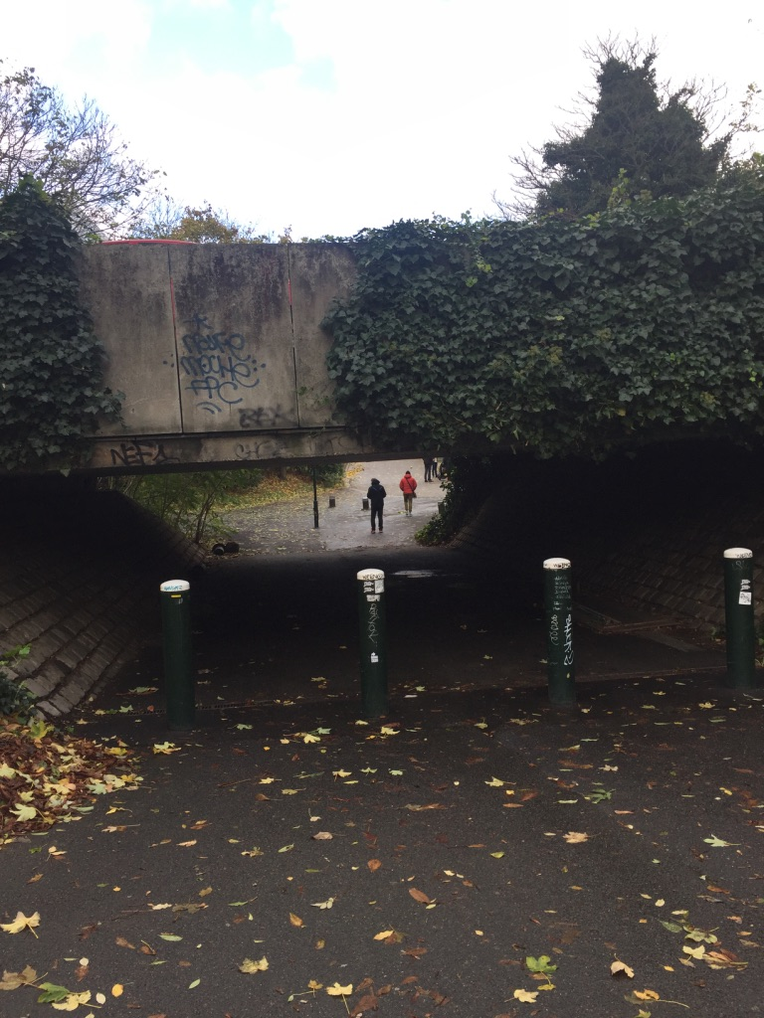
The neighborhoods of Werkbundsiedlung, Geuzenveld-Slotermeer, Flötzersteig, Betondorp, and HBM Housing did not provide additional modes of transportation or make extensive attempts to attach to the transportation of the city. The neighborhoods themselves are at a small scale and do have a high level of walkability within them, but this accessibility does depreciate as an inhabitant leaves the neighborhood. It is important to note that Betondorp and Geuzenveld-Slotermeer are located in a city that has an extensive cycling system, with a cycling culture already in place, making these areas already more accessible even though it was not a part of the suburban design. Additionally, the urban layout varies between these projects and it does influence the orientation aspect of accessibility. The Viennese neighborhoods of Werkbundsiedlung, and Flötzersteig maintain a winding layout with streets merging and bisecting without any higher order, creating interesting, but confusing streetscapes (Stern, 2013). In contrast, the Dutch neighborhoods of Geuzenveld-Slotermeer and Betondorp have a larger organization to the neighborhood, Geuzenveld-Slotermeer with central green spaces, and Betondorp with diagonal streets leading to its central public space, directing some sort of orientation (Stern, 2013; Searing, 1987).
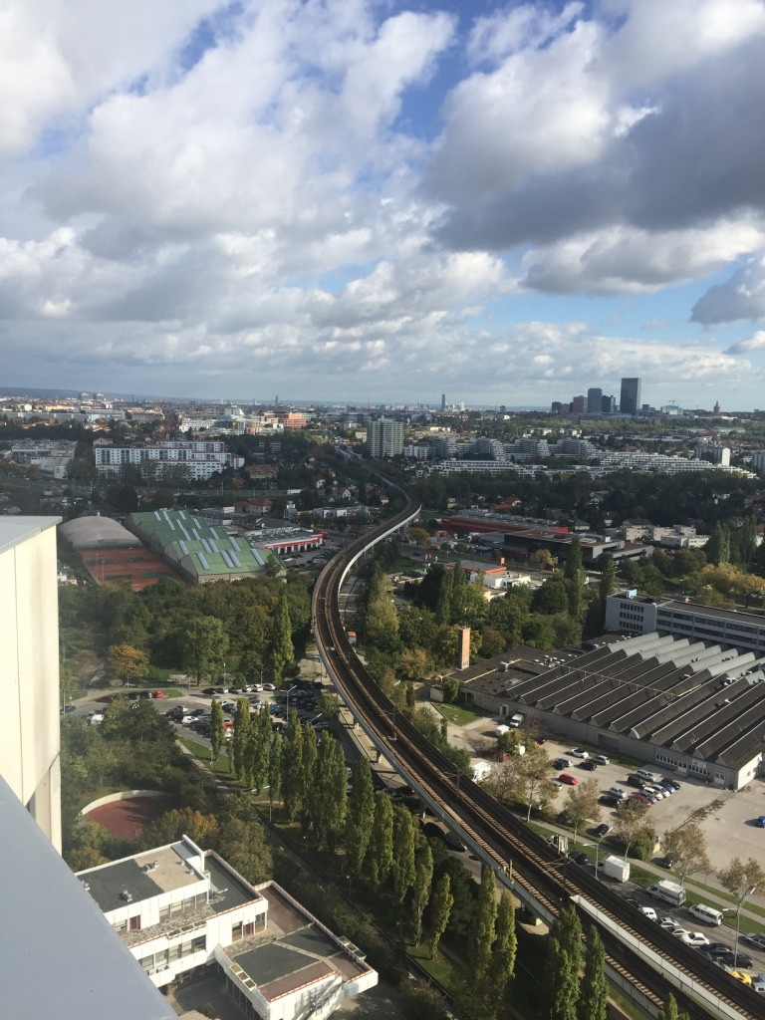
In contrast, the Tours Aillaud does not provide successful accessibility and the scale and orientation of the neighborhood make it a difficult area to navigate by foot. To start, the Tours Aillaud is poorly connected to one metro, and has minimal safe walking paths to get there. Additionally the space surrounding the tours lacks a hierarchy, and the similarity of the buildings prevents using the buildings for orientation. In contrast, the development of Créteil followed the development of the metro, and it was extended every time to meet the demand (Créteil, 2012). Additionally, as the development expanded, bus and walking are available, and integrated into the space. This means that even though the space was developed over time, and there is not a clear urban scale plan, it is still easy to navigate.
Figure 8 Tours Ailluad Accessibility and Orientation: View of the public pdestrian path leading to the metro station.
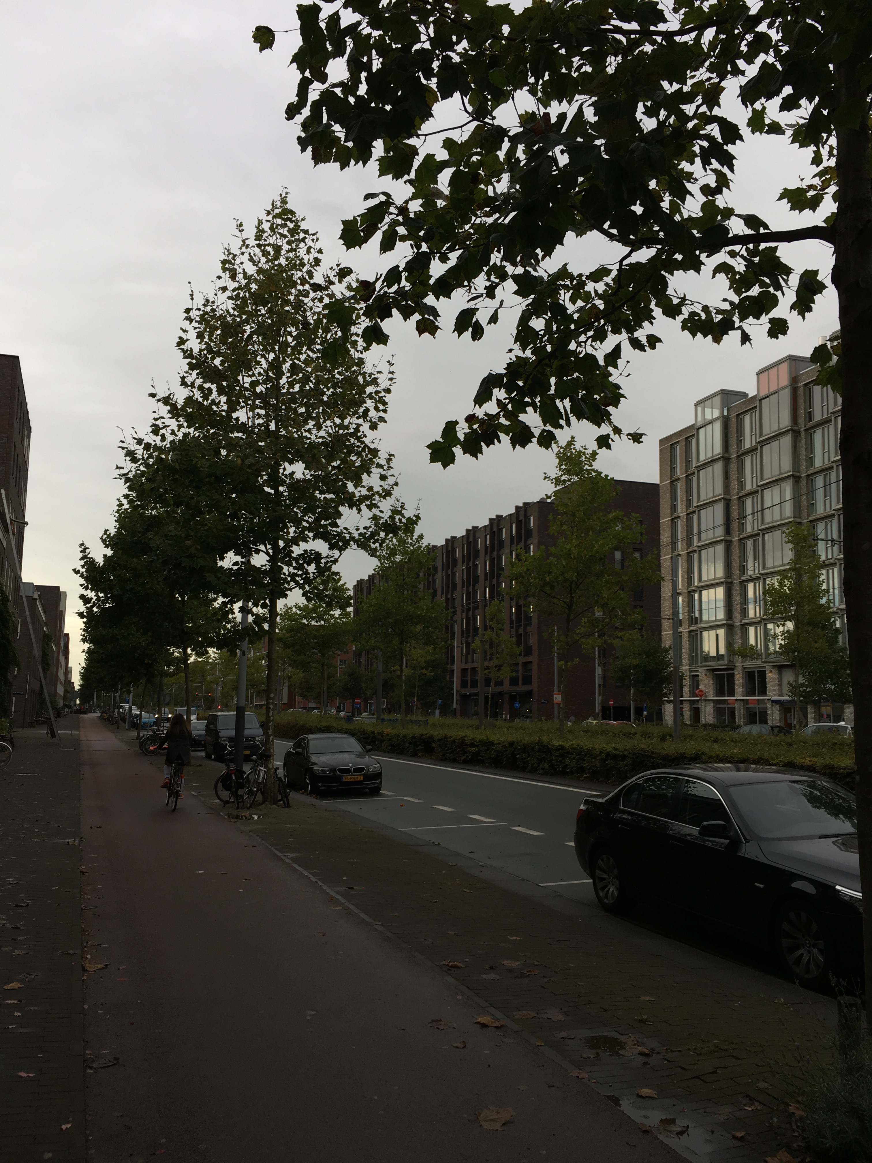
In comparison to a slower continuous development, Alt-Erlaa was built as a singular project without additional accessibility, but transportation was added later to support the development. What is now the main metro station, which is directly connected to the neighborhood, used to be a tramline that was built years after Alt-Erlaa, and is a big part of its success as a development today (Andel, 2016). Additionally the orientation of Alt-Erlaa is easy to navigate, as the buildings are organized into blocks. In IJburg, in contrast, the tram was built first with the intention to one day become a metro-line (Palmboom, 2015). The tram is central to the main axis of the urban grid, and as a result it is not only easily accessible, but it acts as an indicator for orientation. Additionally, bicycle paths and sidewalks are provided on all main streets maintaining ease of transportation. Lastly, the urban grid development of IJburg had some additional guidelines that allowed for another level of orientation, and to break up the monotony of a grid structure. Developers and architects were allowed to design of the interior the urban blocks with more freedom (Palmboom, 2015). As a result, each block is unique from the rest even though there is a grid hierarchy and as a result the orientation of the suburb is maintained.
Figure 9 Alt-Erlaa Accessibility and Orientation: View from the roof of the connecting metro line.
Figure 10 IJburg Accessiblity and Orientation: View of the main street which provides access to the tram and visual orientation.
When comparing the different suburban developments it becomes clear that accessibility is needed for successful suburban development, and that accessibility is most successful when it provides multiple options of transportation, and considers the orientation of the inhabitant in the urban layout. There are a wide variety of accessibility and orientation applications within these suburban layouts, but regardless of whether it was considered or not, the accessibility and orientation of the suburb directly influences the use of the area. If inhabitants are incapable of getting to or from a suburb, or cannot clearly navigate the space once there, it directly affects the usage of the area. The Tours Ailluad clearly demonstrates how critical that can be; the towers are organized in a random fashion that eliminates any street orientation. Additionally, the similarity in building size and appearance further prevents orientation, and as a result it is difficult to navigate. This is compounded by the fact that public transit access is difficult and the landscape makes other transportation options, such as a bike, more difficult. Alt-Erlaa, although also a Modern high-rise suburb, has a navigable layout, and has a direct connection to transportation. Lastly IJburg uses its tramline and urban grid as both a navigable marker and means of accessibility.
Mixed Use and Mixed Housing
What is critical in the redefinition of the suburb is the association with its singular residential use. Many professionals I met with discussed how technically, the neighborhood I went to visit is not a suburb, because it is either no longer on the urban edge, or it contains more than residences, or that it has different types of residences. Including the idea of mixed use and mixed housing in suburban development is critical for cultivating a community environment and generating resilience and flexibility of the neighborhood. Providing other amenities such as local shops generates local business and activity, and inhabitants can stay in the area as they complete their daily tasks. Providing different housing typologies provides resilience and flexibility as it creates neighborhood diversity, and accommodates people at different stages of life. Past examples of suburbs with mixed use and housing, does not reach the same level of implementation as it is today. Planners today focus on providing uses for residents that extend beyond living, and are within reach, and consider the needs of a wide variety of inhabitants.
The suburbs of Werkbundsiedlung, Geuzenveld-Slotermeer, and Flötzersteig, did not consider providing mixed housing as necessary. These neighborhoods are traditional in their function and serve only as a residential environment providing detached and semi-detached residences. Additionally, these neighborhoods did not provide mixed uses within the neighborhood, but relied on the surrounding environment. Betondorp, in contrast, maintains some mixed housing and mixed use by providing different size houses and by organizing public functions at a central square in the center of the development (Stern, 2013; Searing, 1987). The HBM Housing did not utilize mixed use, and additionally provided apartment style housing offering some mixed housing, in contrast to the traditional suburbs. The neighborhood today relies on the surrounding urban environment, and first floor shops to support the mixed use, but upon the time of construction it was a city expansion, and mixed use was not directly considered.
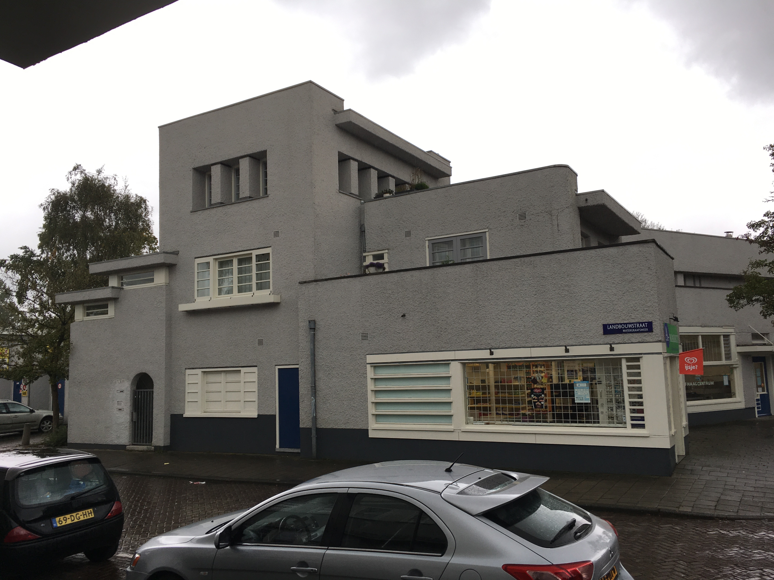
Additionally, the town of Créteil developed mixed use and housing over time following the housing demand as the area expanded. There was not a formal structure, but the neighborhood adapted as the needs changed (Créteil, 2012). As a result, today the area provides multiple choices, but they usually very per block, and are not integrated further. There is however, first floor mixed use scattered throughout the neighborhood. The Tours Aillaud was a structured plan that, like the traditional suburban developments, also did not provide mixed use or housing, even though the high-rise urban form contrasts drastically. The apartments do not provide a wide variety of housing typologies, and the first floor acts only as an entrance to the building, there are no other uses.
Figure 11 Betondorp Mixed Use and Mixed Housing: View of a shop in the central square in the suburb.
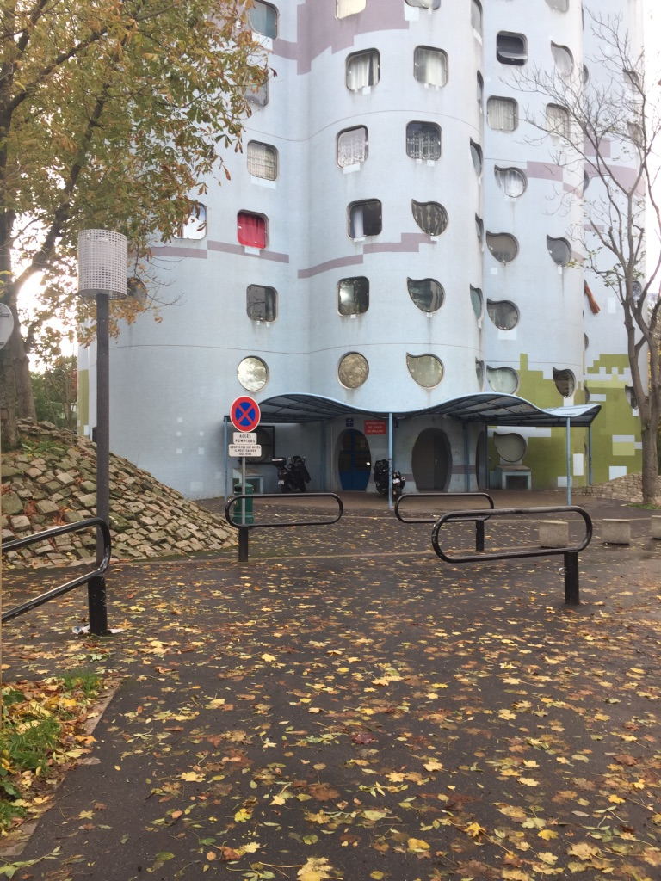
Lastly, IJburg and Alt-Erlaa provide mixed housing and mixed use in very different urban forms. Alt-Erlaa, although organized housing into a high rise structure, made sure to include a wide variety of housing types, and incorporate public spaces both at the ground level and at various floors of the building blocks (Andel, 2016). Residents not only have access to amenities they need, such as a hospital, stores and a school, but also the option to downgrade or upgrade the size of their home without leaving the complex if desired. IJburg generated mixed use and mixed housing by allowing flexibility in the development and providing a series of guidelines to architects that created this diversity. First, there was a required diversity of housing types to be provided within the development. Second, all buildings, regardless of location, were required to have a higher ground floor ceiling height (Palmboom, 2015). This ensured flexibility of the function of the ground floor, and that what once started as a residence can become a store, or vice versa. Together, both of these requirements ensured the flexibility and resilience of mixed use and mixed housing in the suburban development.
When comparing the suburban developments it becomes clear that there is a wide variety of provision of mixed use and mixed housing within suburban developments. Some suburban developments made a clear effort to provide it, while others did not. And that regardless of whether mixed use and mixed housing is provided or not, it has a direct effect on the types and use of public spaces in the neighborhood, and the diversity of inhabitants. Additionally, these two elements work together, and providing both of them makes them more successful. The diversity of housing provides inhabitants at different stages of life to live within one community; this provides more business opportunities, as there is a diverse market for the mixed uses to build from. The neighborhood of Betondorp, for example, provides mixed use at the center of the suburban development, but is limited in its provision of mixed housing types. As a result, the provided mixed use is limited. In contrast, the Tours Aillaud did not provide any mixed use or mixed housing. This has a drastic effect as there is not only limited diversity, but the public space has no means of activation. Lastly, IJburg implemented both mixed use and mixed housing from the beginning of the development through guidelines and requirements for architects and developers. As a result the area, from the beginning is active and diverse, and is prepared to adapt and change in the future.
Figure 12 Tours Ailluad: View of the first floor entrance to a residential tower that does not have any mixed use.
Conclusion
Figure 13 IJburg Mixed Use and Mixed Housing: View into a smaller street intersection. It is visible the variety of housing availiable, and the height difference at the first floor allowing for mixed use to occur.
When comparing the Garden Suburb and Modern Suburb developments in the cities of Amsterdam, Paris, and Vienna it becomes clear that the suburban topics of The Use of Green Space, Social Interaction and Personalization, Accessibility and Orientation, and Mixed Use and Mixed Housing have cumulative effects upon each other and the suburban development. This means that the topics are more successful when they are combined since, achieving one topic within suburban development can create opportunities for another. Take for example how the topics combine to place a new emphasis on public space. Providing mixed use and mixed housing provides easier opportunities for social interaction and personalization because the two topics together place a new emphasis on the use and function of the street. Inhabitants are on the street using the different amenities provided in the neighborhood, and the higher density and diversity of housing generates a larger market. This generates activity that allows for personalization and identity of a neighborhood to occur. Accessibility and orientation support this by not only providing ways of arriving to the neighborhood, but also assisting in navigation of the neighborhood. Lastly the use of green space also supports the use of public space by providing green space that can function as public space, such as parks or public gardens. In the past, both Garden Suburb and Modern Suburb ideals did not focus on the importance of public space. Take for example the neighborhood of IJburg, the diversity of housing requirements and ceiling heights ensure the flexibility of mixed use, the tram provides easy access and orientation, and the variety of parks and views includes green space as part of the public space.
In addition, these topics also combine to demonstrate a critical need for access to and from a suburb. Mixed use and mixed housing provides a density that is capable of supporting multiple modes of transportation within an area. A certain number of people are required to make public transit cost efficient, and mixed housing creates opportunities for a higher density that can support public transit. Additionally, the mixed uses encourage other smaller modes of transportation such as walking and cycling when moving between the conveniently located public spaces and amenities. It is also important to note that the smaller modes of transportation minimize the feeling of crowdedness at a higher density. If inhabitants are walking or cycling then there is less noise and people occupy less space than other means of transportation, such as a car. The use of green space supports access by adding to the walkability of an environment, and by providing the desired natural environment to inhabitants at a higher density. Social interaction and personalization also assist with access by encouraging the use of multiple modes of transit, by creating both activity and identity. In the past, both Garden Suburb and Modern Suburb ideals did not focus on the importance of accessibility. Take for example the neighborhood of Alt-Erlaa, the high-rise parabolic towers generate a high-density neighborhood, and support the use of the public spaces below. At the same time inhabitants have multiple means of transportation, and the private balconies provide an interactive green environment, minimizing the feeling of living in high density.
Lastly, these topics combine to generate a sense of identity within the suburb to maintain its success. Mixed use and mixed housing provides opportunities for inhabitants to move within the neighborhood without moving out during different stages of life. Social interaction and personalization generate a community by inducing interaction and activity as well as the physical identity of the façades. Accessibility and orientation and the use of green space support the identity of the area by helping to generate the physical identity of the environment. When considering the redefinition and criteria of a successful suburb, it is important to understand that there is not one correct formal answer. Meaning that its urban plan and design is not limited in its ways to achieve providing the topics within a development. In the past, both Garden Suburb and Modern Suburb ideals placed too much focus on the formal identity, sometimes with negative results. This is most obvious when comparing IJburg and Alt-Erlaa, whom have drastically different formal plans, but both achieve the criteria discussed in this paper. What is most important is that the goal and intent of each topic is maintained and achieved, and because of the cumulative effects there are multiple ways of achieving the goals of a redefined successful suburb.

References
ANDEL, W. L. 2016. 40 Years of Alt-Erlaa, Vienna Austria, Austria.
CRÉTEIL, C. O. 2012. Cristolean Urbanization [Online]. http://www.ville-creteil.fr: City of Créteil. Available: http://www.ville-creteil.fr/lurbanisation-cristolienne-un-puzzle-urbain [Accessed November 13 2017].
DIJKSTRA, C., REITSMA, M. & ROMMERTS, A. 1999. Atlas Amsterdam, Bussum, Uitgeverij Thoth.
ESTEREN, C. V. 1997. The Idea of the Functional City, The Hague, EFL Publications.
EVENSON, N. 1979. Paris: A Century of Change, 1878-1978, The United States, The Murray Printing Co.
FEUERSTEIN, G. 1974. Vienna: Present and Past, Vienna, Austria, Renate Welsh Jugend und Volk.
FORDE, T. 2017. Peep Through the Wondrous Windows of the Tours Aillaud in This Colorful Photo Series [Online]. https://www.archdaily.com: Arch Daily. Available: https://www.archdaily.com/884352/peep-through-the-wondrous-windows-of-the-tours-aillaud-in-this-colorful-photo-series [Accessed 10-12 2017].
HATZ, G. 2008. City Profile: Vienna. Cities.
KOSTOF, S. 1991. The City Shaped, Urban Patterns and Meanings through History, New York, NY, Bulfinch Press.
PANERAI, P., CASTEX, J., DEPAULE, J. C. & SAMUELS, I. 2004. Urban Forms: The Death and Life of the Urban Block, Oxford, United Kingdom, Architectural Press.
PLAMBOOM, F., VELDHUIZEN, H. V. & SCHAAP, T. 2015. Amsterdam IJburg: Urban Guest in Nature. Amsterdam, The Netherlands: City of Amsterdam, Bureau Palmbout.
REQUAT, F. & GLÜCK, H. 2017. Wohnpark Alt-Erlaa [Online]. http://architectuul.com. Available: http://architectuul.com/architecture/wohnpark-alt-erlaa [Accessed 01-10-2017 2017].
SARNITZ, A. 2003. Vienna: 1975-2005 New Architecture, Austria Holzhausen Druck & Medien GmbH.
SCHOT, J. 2001. Seven Million Cubic Meters of Sand, Amsterdam, The Netherlands, Stiching Touching Visuals.
SEARING, H. 1987. Amsterdam's Concrete Garden Suburb. Assemblage, The MIT Press, 108-143.
STEENBERGEN, J. J. M. & BEMMELEN, R. J. V. 2011. Land. If You Don't Have it, Create it. The Case of IJburg, Amsterdam. Irrigation and Drainage, 60, 4-10.
STERN, R. A. M., FISHMAN, D. & TILOVE, J. 2013. Paradise Planned, The Garden Suburb and the Modern City, United States, The Monacelli Press.
VERLAG, T. P. G. 2014. Atlas of the Functional City: CIAM 4 and Comparative Urban Analysis, Bussum, The Netherlands, THOTH Publishers.
WORLD, A. 2017. Tours Aillaud [Online]. http://www.alluringworld.com. Available: http://www.alluringworld.com/tours-aillaud/ [Accessed 01-11 2017].
ZANDBELT, D. & BERG, R. V. D. 2003. Paris: L'historie se Repete, London, The United Kingdom, London GLA's Spatial Development Strategy.

Appendix
List of Interviewees
- Frits Palmboom – Founder of Palmbout Urban Landscapes, Van Eesteren Chair at Delft University of Technology
- Elisabeth Gruber – Post-Doc Researcher, University of Vienna
- Volkmar Pamer – Target Area Coordinator Liesing Centre, Municipal Department 21 (City of Vienna), Urban District Planning and Land Use, European Urbact Program Sub>Urban Expert
- Paul Grohmann – Municipal Department 18-Urban Development and Planning Section (City of Vienna), Urban and Regional Development, European Urbact Program Sub>Urban Expert
- Ton Schaap – Department of Physical Planning and Sustainability, City of Amsterdam
- Claire Carriou – TBD
- Esther Reith – Department of Physical Planning and Sustainability, City of Amsterdam
- Maarten van Tuijl – Founder of Temp Architecture, Lead Expert of European Urbact Program Sub>Urban

