Planning Truly ‘Public’ Spaces for Social Inclusion and Equity:
Measuring the Publicness of Public Spaces in Medellín, Colombia
Evan Todtz
Master of Science in Urban Design
Master of Science in Community & Regional Planning
UT School of Architecture, The University of Texas at Austin
email: etodtz@utexas.edu | mobile: 469.662.5763
address: 611 E 43rd Street, Apt A, Austin, TX 78751
Abstract
Reflective of the evolving national culture and identity of public space in Colombia, the city of Medellín has been planning and designing new public spaces to promote social inclusion and equity. Plagued by paramilitary and narcotrafficking violence throughout the 80s, 90s, and early 2000s, Medellín has since been recognized as the 2013 ULI/WSJ “Innovative City of the Year” and received the 2014 Lee Kuan Yew World City Prize, due in no small part to their ongoing efforts to leverage new public spaces to advance social equity outcomes. At the same time, Medellín remains one of the most economically and socially unequal cities in Latin America. To better understand this phenomenon, I travelled to Medellín in the summer of 2017 for approximately one month to document public spaces across the city, seeking to quantify the equity impacts that these contemporary public space projects provide by observing how current residents occupy and inhabit these public spaces.
The study employs Varna’s Star Model framework to assess the publicness of public spaces as the basis for observations, arguing that the publicness of a given space is a strong indicator of the space’s potential to achieve sustained social equity impacts over time (2014.) In accordance with the Star Model, I documented five components of public space: physical configuration, ownership, control, civility and animation (Varna, 2014). Findings revealed a moderate to high degree of publicness in each of the selected public spaces, reinforcing the ongoing efforts that the city (and the nation) have made towards creating quality public spaces for all. By upholding this sense of publicness, these public spaces encourage social integration between socioeconomic classes and generate local economic activity. By using the concept of publicness as a framework to assess public space, local planners and designers can better determine how particular components of public spaces in their own communities might inhibit or advance certain social equity outcomes.

Building Public Space Culture in Colombia: Pre-Colombian to Contemporary Paradigms
The Republic of Colombia has been working to subvert its tumultuous and violent history by striving to build a contemporary public space culture which promotes shared national identity and social equity. This culture has been evolving ever since the arrival of the region’s first inhabitants, whose cosmological perspectives centered on the harmonious spiritual unity between humans and nature (Simons, 2004; Viveiros de Castro, 1998). Upon the arrival of the Spanish in 1509, however, these spiritual ties to nature were largely severed in favor of a strict set of urban planning mandates collectively known as the Laws of the Indies. Amongst these planning principles, the central plaza was established as the most prominent public space in the settlement, centrally located and proportioned in scale to the total population (Wagner, Box, & Kline Morehead, 2013). The plaza was conceived as a purely public space; however, as the “political and economic dependency of colonialism” increasingly stratified socioeconomic classes, the plaza’s character drastically changed (Kinsbruner, 2005; Angotti & Irazábal, 2017). These class tensions ultimately climaxed in the Bolivarian liberation movement of the early 19th century.
From independence through the 20th century and well into present day, Colombian life has been marred by high levels of violence. In 1986, during the peak of the nation’s contemporary violence, Colombia introduced the novel practice of regional elections to allow citizens to vote directly for their own representatives at the State (Departmental) and local (mayoral) levels. The former Director of Planning for the City of Medellín cites this process of political decentralization as foundational to forging a more advanced, democratic urban society which allowed cities to more effectively address urban violence while also laying footings for the new Colombian constitution which was promulgated in 1991 (Pérez Jaramillo, 2017). The Constitution of 1991 enumerates many new rights, of which includes the State´s responsibility to protect the integrity of public space and to maintain its use for the common good (Constitución Política de Colombia, 1991). Within several years of the ratification of the new constitution, significant changes in governance began in Colombia, most notably with the subsequent elections of two of the most important figures in the formation of the Colombia´s contemporary public space culture (Berney, 2010).
These two leaders, Antanas Mockus and Enrique Peñalosa, served a combined three terms as Mayors of Bogotá between 1995 and 2003. Mockus was most well-known for his inventive means of promoting social etiquette in public spaces through educational exercises such as incorporating mimes at street intersections to encourage pedestrians to wait for crossing signals (Mockus, 2005). Peñalosa, on the other hand, focused on creating more and better quality urban spaces, as well as calling for the recuperation of existing public spaces through the removal of informal (unpermitted) street vending activities (Peñalosa, 2005). These collective views were ultimately codified in the City Development Plan entitled Forming City (Peñalosa, 2005). In addition to these municipal development plans, other policy tools such as Territorial Organization Plans (POT), regulations adopted from these POTs, and the Municipal Police Code continue to influence public space culture in Colombia today (Mockus, 2005). These policy tools also prove useful to planners in Medellín, although the city’s history with violence, paired with its geographic complexity, have presented even greater urban challenges to overcome.
Public Space Culture in Medellín
Medellín’s contemporary planning practice is paradoxical: while receiving numerous accolades from the global planning and design communities for their efforts to advance social equity, the city continues to be one of the most economically and socially unequal cities in Latin America (Alcaldía de Medellín, 2016). Historic inequity can be traced back to the city’s colonial foundations, but notably accelerated in the years following La Violencia in the mid-20th century, leaving over 250,000 dead across the nation and forcibly displacing hundreds of thousands more in a massive rural-to-urban migration (Simons, 2004). This migration, in part, marked the beginning of a population explosion to a metropolis of over 2.5 million inhabitants today (2017 estimates) (Departamento Administrativo Nacional de Estadística, 2005). A current architect for the quasi-governmental entity known as the Urban Development Enterprise (EDU), describes how Medellín’s geography and historic migration patterns drove its current socio-spatial segregation. He explains that the vast majority of the valley had been planned and/or developed by the mid-1950s, but with limited planning authority and facing explosive population growth, many new residents, largely poor, rural families, were forced to settle far outside the city in the steep hillsides where land was available, leaving them socially, economically, and environmentally vulnerable (González Maya, 2017).
These isolated and vulnerable settlements quickly became new territories of urban violence, accelerated by the economic crisis of the 1970s. In response, a Presidential Advisory Council was established by the Republic in 1990 to develop innovative solutions for Medellín’s violence. Jorge Pérez believes that it is from this body that the culture of collective citizenship and identity truly begins: a “top-town, bottom-up” strategy focused on promoting the common good (2017). In 1993, a program known as the Integrated Program for the Improvement of Substandard Neighborhoods (PRIMED), became one of the first planning efforts in Medellín to attempt to physically integrate disparate urban neighborhoods through critical infrastructure projects, but failed to cultivate a strong sense of resident ownership or civic pride (Betancur, 2007). To promote more community-centered planning, the Integrated Urban Project (PUI) replaced PRIMED in 2004 (Betancur, 2007). A former EDU employee reiterated the importance of this shift, stating that “the most valuable of all of Medellín’s process [was] that we learned to listen” to the community (Ortiz, 2017).
This commitment to social equity and the revaluation of community input in the decision-making process exemplify what was originally termed the “social urbanism” movement and is today referred to as “pedagogical urbanism” (González Maya, 2017). Alejandro Echeverri, former Director of the EDU, explains that “social urbanism” seeks to promote quality planning and design while also enhancing the environmental and economic viability of the urban peripheries through, in part, the delivery of quality public spaces which generate tourism and spur local economic development (Echeverri, 2005). As such, the EDU frames their current public space strategy under two main initiatives: delivering high quality design to the peripheries through locally-oriented parks built with quality materials, and renovating highly accessible downtown parks to ensure universal access to quality public spaces (González Maya, 2017).
While projects in the city center usually allow for larger-scale interventions and are generally better linked to regional transit, the EDU sees the creation of neighborhood-oriented public spaces as an opportunity to better connect residents (to public transit) and to create new neighborhood centers (González Maya, 2017). Despite the dearth of public space across the city, many local planners agree that the culture of shared public space is much more robust amongst the lower socio-economic strata of Colombia compared to more affluent citizens who seek to emulate “American” models of public space such as auto-oriented shopping malls or private clubs (Ortiz, 2017). Building contemporary public space in Medellín then becomes a delicate balance between investing in modest public space projects in the peripheries versus larger-scale interventions in the city center with the additional task of changing more affluent residents’ existing perceptions of public space (González Maya, 2017). As such, this study seeks to measure the ‘degree of publicness’ for a cross section of public spaces across the city to assess the extent to which these spaces contribute towards an increased sense of social inclusion across all socio-economic classes.
Research Methodology
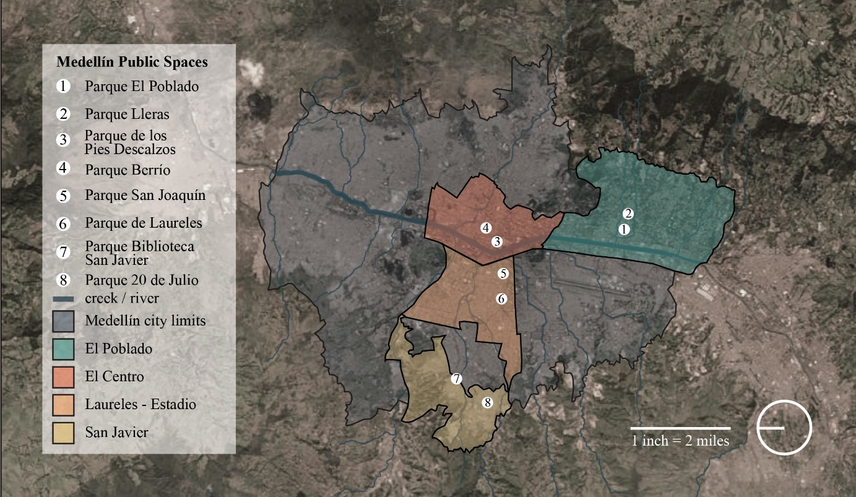
With these questions in mind, I travelled to Medellín in the summer of 2017 to document a diverse set of public spaces across the city, seeking to better understand how residents occupy and inhabit different types of public spaces in order to begin to qualify some of the impacts of these projects in their goals of achieving more equitable social and economic impacts and sentiments of social inclusion. In all, I documented eight (8) public spaces in Medellín, Antioquia, Colombia over the course of approximately one month. These 8 public spaces are located in four (4) separate districts (communes) of the city, each with its own unique development patterns, planning history, and social identity. The communes studied include: El Poblado, El Centro (Downtown), Laureles – Estadio, and San Javier. The historical context for each commune will be presented along with the study findings located in the subsequent section.
Figure 1: The public spaces studied and their local communes are illustrated in the map above.
In order to conduct my research, I relied primarily on four types of research methods: archival and academic research, semi-structured interviews with key actors working in public space planning and design, informal interviews with users of public spaces, and on-site documentation in adherence to the Star Model of Public Space framework. The Star Model, derived from a recent three-year academic research effort, is a novel assessment tool originally conceived as a way to critique the quality and impact of the growing number of contemporary public space projects that aim to revitalize city centers or post-industrial waterfronts. The book published from this research presents three in-depth case studies, all waterfront sites in Glasgow, Scotland, which all share similar: development processes (newly built), physical configurations (size and scale), program (recreation and entertainment), and project goals (riverfront revitalization and increased tourism) (Varna, 2014). The Star Model is used to provide a critical analysis of each of these major urban investments, offering three central contributions to urban planning practice. First, it provides a simple, low-cost framework for planners to use to assess public spaces in their own cities. Second and third, the results of the study can be used to both inform and encourage more informed decision-making and organizational cooperation by the main actors in the development process regarding project siting, design, financing, and maintenance (Varna, 2014).
The Star Model centers on five equal components of public space, each with its own set of unique indicators to assess the qualitative aspects of a given public space. These components include: physical configuration, the macro- and micro-design characteristics of the site and its adjacencies; ownership, the site’s legal deed (i.e. public vs. private); control, the various technologies, design, signs and actors present in policing or controlling a given space; civility, the level of site maintenance and management; and animation, the presence of a large and diverse amount of people and activities in a given space (Varna, 2014). Each component’s unique indicators are individually assessed on a nominal scale from 1 (very poor) to 5 (excellent) using pre-established characteristics for each value. After scoring each individual indicator, the component then receives an intermediate score using an equally weighted average of the indicators which comprise it. The final composite score is the equally weighted average of all components.
Although the Star Model indicators have undergone significant refinement, it was necessary to adjust several to better reflect Colombian public space culture. For example, a public transit indicator was added to the physical configuration component since Medellín explicitly outlines public accessibility as part of its equity framework for delivering public spaces and the majority of residents do not have access to a personal automobile (Álvarez Correa, 2015). Second, the control indicators were requalified to better represent the control agents and signage present in Colombian public spaces, such as including all behavioral signage (to encourage/discourage) and a greater tolerance for heightened police and private security presence. Finally, animation indicators were requalified to better reflect the elevated volume of people and activities in Medellín’s public spaces, calculated by averaging the amount of street vendors and entertainers and then adding and averaging the number of activities to arrive at the final component score.
Research Findings: Measuring the ‘Publicness’ of Public Spaces in Medellín
The main results of the publicness study will be presented by commune, followed by an individual Star Model for each public space and a discussion of the general trends observed. As a publicness study, scores favor universally accessible and inclusive spaces over semi-public or semi-private spaces. While it is important to acknowledge the vital role which these other spaces provide to local residents, this study argues that these spaces should be complementary, rather than substitutive of purely public spaces which aim to promote broad social inclusivity. Additional scoring information and notes for each of the public spaces studied will be included in an appendix.
El Poblado, the site of the region’s first colonial settlement and now the most affluent commune in Medellín, attracts many foreign investors and tourists annually. This massive influx of international capital has led to unfettered urban growth, resulting in sprawling, auto-centered residential, retail and office development across the commune. Despite this reality, El Poblado also maintains many quality public spaces, including two of the spaces in this study: Parque Lleras and Parque El Poblado. Both of these spaces scored identically, registering at 4.10 (on the 5.0 scale). While rated highly for their material quality, excellent maintenance and appearance, and social vibrancy, both scored worse than other spaces studied regarding their macro-spatial connectivity and the presence of noticeable control elements. For example, both spaces are located adjacent to the commune’s main west-east arterial, Calle 10, which greatly discourages cycling and walking to these spaces. However, as the heart of Medellín’s tourism industry, pedestrian activity remains fairly consistent throughout the day and sharply increases in the evenings as visitors gather to patronize local bars and clubs. It is perhaps due to this high volume of international tourists in public spaces that elements of control are also highly visible. For example, a police substation (security outpost) has been sited within Parque El Poblado itself, resulting in frequent police patrols here (as well as Parque Lleras), particularly in the evenings, where tourists and residents alike are asked to produce photo identification. Furthermore, large signs throughout Parque Lleras discourage particular types of behaviors, such as drinking liquor or listening to loud music. When questioned, some visitors said these elements made them feel safer, while others felt that these control mechanisms made spaces feel overly policed. Given the high level of control, which was more pervasive than in any of the other spaces studied, these spaces feel like they cater more towards tourists than to local residents, and as such, feel somewhat less inclusive or “public” in their character.
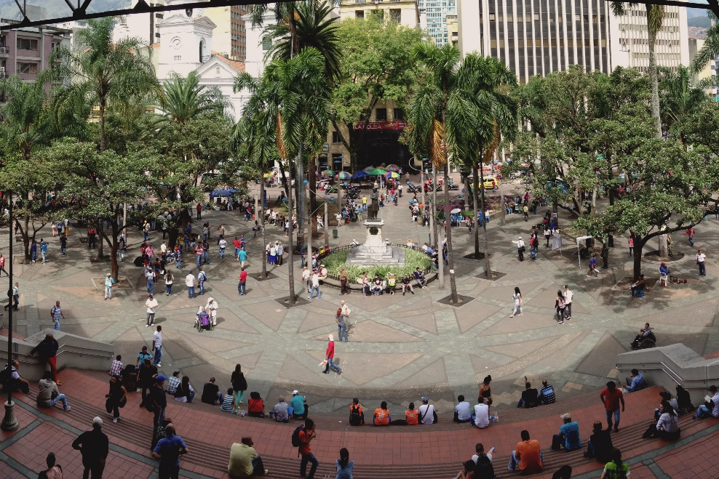
El Centro (Downtown Medellín) lies at the convergence of the city’s public transit system, and therefore, hosts some of the city’s most animated and accessible public spaces. Due to this accessibility, as well as its vital economic importance, the City has been working to revitalize the distressed downtown area, in part through the restoration and creation of more inclusive public spaces. The spaces studied in this area include a renovated public space, Parque Berrío, and a more recently constructed public space, Parque de los Pies Descalzos (Barefoot Park). Parque Berrío lies directly at city center, adjacent to a major Metro rail station. Due to its accessibility, quality design and high level of animation, its overall rating was a 4.23, the third highest rated public space in the study. The social life of Parque Berrío far exceeds any of the other spaces studied. Informal vendors, such as coffee baristas, fruit salesmen, and shoe polishers station themselves under the shade of leafy tree canopies, while friends congregate outside the Metro station to talk or to listen to live musical performances. Small vending kiosks for rent along the park’s perimeter show evidence of past attempts to deter informal vending, but vendors adapt to their environment. For example, independent vendors can be seen carrying small canisters of fresh coffee throughout the plaza to sell to patrons, filled just moments earlier from the coffee kiosk directly adjacent to the park at a “vendor rate.” For this reason, most Colombian municipalities have begun to loosen the crackdown on informal vending in certain public spaces, provided that the safety and welfare of patrons is not jeopardized. On the other hand, Parque de los Pies Descalzos is located farther away from the bustle of the city center in a much more controlled space operated by the Medellín Public Works company (EPM). As a utility-owned space, the park’s underlying mission is to educate citizens about environmental stewardship through the curation of various play areas for people of all ages centered on engaging with the earth with your bare feet. Furthermore, as an administratively-owned space, private security and EPM staff are on-site at all times to ensure patron safety and adherence to certain rules. For example, the space does not allow informal vending of any sort on the premises, thereby catering more to those visitors who are able to patronize the more expensive kiosks and restaurants adjacent. Informal vendors respond by occupying the opposite side of the street along the edges of the park, attempting to capitalize on cross traffic. Despite the park’s popularity with residents and visitors alike, the control mechanisms present and the ownership structure reduce the park’s score to a 4.04, the second lowest in the study.
Figure 2: Medellinenses gather in the afternoon shade in Parque Berrío
Laureles – Estadio, due west of El Centro across the Medellín River, was mainly developed between the 1930s and 1950s in loose adherence to some of the urban planning principles of the time, such as the Garden Cities movement and early modernism. The two public spaces studied in this commune are Parque San Joaquín, a small, linear neighborhood park, and the Primer Parque de Laureles, the neighborhood heart of Laureles. The Primer Parque de Laureles received a score of 4.28, the second highest in the study. Despite less accessibility to mass transit, the cycling infrastructure present in the park far exceeds any other public space studied, with a bikeshare station and separated cycle track connecting the site from two sides. As the social center of a lively neighborhood corridor filled with many bars and restaurants, the park entertains a variety of diverse uses throughout the day, from joggers in the early morning to lunch crowds gathering under the midday shade to dog owners walking through and playing in the park in the evenings. However, the lower volume of vendors and other animation, paired with somewhat frequent police patrols, lowered the park’s overall score. A similar environment is also present in Parque San Joaquín, which received the fourth highest score of 4.11. Despite the park’s strong accessibility by cycling and mass transit, the smaller scale creates an intimate, almost semi-private environment to the casual visitor. Warm and friendly resident-police interactions during the morning and afternoon patrols by the adjacent police substation add a noticeable, but generally relaxed, control presence. Small groups of neighbors keep the space active throughout the day, allowing kids to play soccer while they gossip and chat over a coffee or play chess. Despite regular foot traffic and many children present, the park remains immaculate, with no visible trash or any signs of wear and tear.
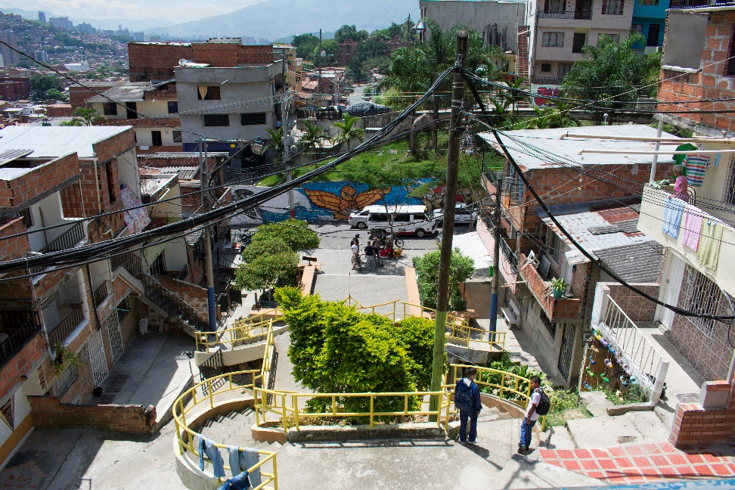
San Javier, the final commune included in this study, is located along the western hillsides at the edge of the city. This largely self-constructed commune has overcome its history as the epicenter of guerrilla- and cartel-induced violence, due in no small part to public space projects and other City-led investments to promote social equity in recent years. This study includes one such high-profile project – Parque Biblioteca San Javier, one of Medellín’s famed library parks – located adjacent to the San Javier Metro Station, as well as Parque 20 de Julio, a recently renovated neighborhood park located a 20-minute walk from the Metro. Parque Biblioteca San Javier received a 4.30, the highest score in the study. The park’s location adjacent to the Metro and integrated bus routes makes it highly accessible, although the elevated site limits pedestrian and cycling access points as well as the potential for street activation along its edges. Despite this challenge, the park remains active with residents of all ages throughout the day. Wear and tear in the lawns from heavy foot traffic is present, but is comparable to other public spaces in the city. Informal vending is not prevalent, though a cafeteria and kiosk selling snacks and drinks provide visitors light snacks and drinks. Private security guards control entry/exit from the library itself, but patrols in the park itself are quite uncommon. What elevates this park to the top of this study is the fact that in spite of its modest site and surroundings, it embodies a space with strong resident ownership. Community garden plots thrive, teens practice dance routines, children eat candy and fly kites, and grandparents sit on benches snacking and chatting with neighbors, all while tourists patronize the library and take photos of the neighborhood from the elevated vantage point. Parque 20 de Julio, on the other hand, scored only 3.02, the lowest score in the study. The park’s macro and micro configuration as well as its (lack of) animation are the primary factors influencing the score. First, its midblock location between residential parcels limits cross traffic. Adjacent residents use the park as their own front yard, with laundry hung out to dry and families chatting in outdoor chairs in the late afternoon. Low shading results in very low usage throughout the day, with the heaviest use in the early evening when children come to play soccer or neighbors gather to share a drink in front of the adjacent corner store. At the same time, this occupation does not translate into a strong sense of ownership or stewardship. The park is overgrown with weeds in some places and barren in others, with trash strewn throughout the gardens and the walkways. Ultimately, this lack of civility and ownership significantly lowered the overall publicness observed in this space.
Figure 3: Patios of private residences face into Parque 20 de Julio
The graphic on the following page presents the overall scores for each of the 8 public spaces documented in this study, beginning with the highest score, Parque Biblioteca San Javier (4.30) in the top left, and ending with the lowest score, Parque 20 de Julio (3.02) in the bottom right. One should note that the subtle variations observed should not be taken as absolute values, but rather a snapshot of the current publicness of the space. The most important take-away for planners comparing these models is to quickly understand how each individual public space component contributes towards the overall publicness of the space, thereby revealing opportunities to affect meaningful change. For example, by adding a bikeshare station to a poorly connected space or by reducing police patrols in a highly controlled public space, perceived publicness could be drastically enhanced. The moderate to high publicness for each of the public spaces studied reinforces the ongoing efforts that the city (and the nation) have made towards creating quality public spaces for all.
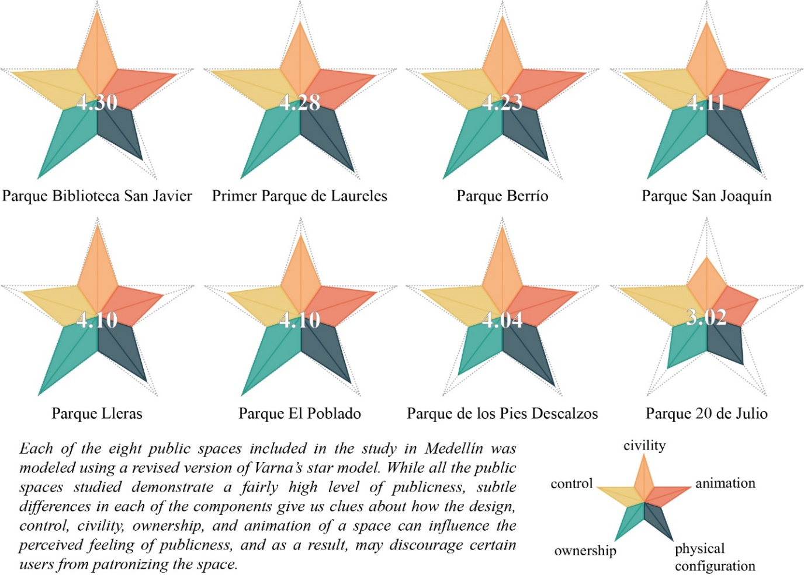
In addition, it is important to remember that the perceived publicness of a space and the incidence of strong local (resident) ownership of that space are not contrary conditions in tension with one another, but are rather complementary qualities which together can promote more dynamic and inclusive public spaces. In fact, the most static components across all the spaces studied were a sense of ownership and control. This may also reflect researcher bias, as the public spaces chosen were all state-funded projects that were perceived as safe to occupy as an international researcher. I sought to mitigate this bias by selecting spaces across the city, constructed in different contexts and inhabited by different user groups. Conversely, the most varied components – civility, animation, and physical configuration – demonstrate marked discrepancies in how users themselves treat the spaces (rather than maintenance schedules), the fluctuating volumes of users throughout the day and between spaces, and the connections to adjacent land uses and mass transit.
Figure 4: Varna star models for each public space studied measure the assessed level of publicness
Discussion: Publicness as an Indicator of Sustained Social Equity Outcomes
This study frames publicness as a strong and reliable way to measure the potential of a given public space to achieve sustained social equity impacts over time. I agree with contemporary urban planners in Medellín that social equity is not achieved by the siting of new public space projects in marginalized neighborhoods alone (although, this too is of vital importance). As such, this study moves beyond framing social equity only in terms of equal access to public space. Rather, it employs a well-developed publicness framework (the Star Model) to critically assess what qualities public spaces possess, and which of these qualities are most vital to producing and reproducing positive social equity outcomes. By assessing the strengths and weaknesses of a given public space, planners can work to change and improve them by measures such as forging new or strengthening existing organizational partnerships or by pursuing physical design interventions which aim to enhance social equity outcomes in their own communities.
The study demonstrates several key findings. First, variations in site design, material quality, maintenance schedules, and local economic development opportunities all result in measurable and significant social impacts for residents, particularly when projects are sited in traditionally resource-poor areas of the city. Higher scores are recorded for spaces designed for high accessibility and those which allow more informal economic activity and spontaneous activation by residents over tourists. Therefore, we see well-maintained and active spaces such as Parque Berrío and the Primer Parque de Laureles modestly outscoring Parque El Poblado and Parque Lleras, which cater more to visitors and maintain high levels of control. However, more active and well-utilized spaces do not always equate to the highest level of publicness. For example, Parque de los Pies Descalzos has many patrons present at any given time, but the space ranked second lowest in publicness due to other ownership and control factors. Finally, the state’s commitment to planning and designing these public spaces with residents has promoted a sense of ownership and civic pride to varying degrees. Findings reveal that the ownership structure and the observed civility of a given public space significantly influence its perceived publicness, particularly with respect to the role of local residents in the treatment and upkeep of their local public spaces. This discrepancy cannot be more clearly illustrated than by the strong resident patronage and sense of ownership and care present in Parque Biblioteca San Javier versus the substantial local usage but lack of care or general upkeep on the part of the neighbors of Parque 20 de Julio. While sharing relative proximity and similar socioeconomic profiles, the stark differences observed between these two spaces resulted in them receiving the highest and lowest scores in the study, respectively.
In conclusion, I argue that the publicness of a given public space is paramount in order to ensure sustained social equity impacts. The erosion of publicness discourages the inhabitation of public spaces, and thus limits the potential for social integration between socioeconomic classes and local economic exchange. In Medellín, a city where systemic economic inequality and violence have generated extreme social stratification, publicness must be upheld to ensure sustained social equity impacts. The study findings validate the Star Model’s ability to effectively identify strategic opportunities for planners to create and sustain more equitable public spaces.

References
Alcaldía de Medellín. (2016). Medellín y su población. Technical Support Document, Alcaldía de Medellín, Departamento Administrativo de Planeación.
Álvarez Correa, V. A. (06 de December de 2015). Por cada 3 habitantes hay un vehículo rodando en Medellín. El Colombiano. Obtenido de http://www.elcolombiano.com/antioquia/movilidad/en-medellin-transita-un-carro-por-cada-tres-habitantes-EB3232363
Angotti, T., & Irazábal, C. (March de 2017). Planning in Latin American Cities: Dependencies and "Best Practices". Latin American Perspectives, 44(2), 4-17.
Berney, R. (November de 2010). Learning from Bogotá: How Municipal Experts Transformed Public Space. Journal of Urban Design, 15(4), 539 - 558.
Betancur, J. (2007). Approaches to the Regularization of Informal Settlements: The Case of PRIMED in Medellín, Colombia.
Constitución Política de Colombia. (4 de July de 1991). Colombian Constitution of 1990. Colombia.
Departamento Administrativo Nacional de Estadística. (2005). Estimaciones de Población 1985 - 2005 y Proycecciones de Población 2005 - 2020 Total Municipal por Área. Municipal and Departmental Population Estimations and Projections, DANE.
Echeverri, A. (2005). Hacia el urbanismo social: El caso de Medellín. En G. Murillo Castaño, & V. Gómez Segura (Edits.), Redefinición del espacio público. Colombia: Universidad de Los Andes; Woodrow Wilson International Center for Scholars.
González Maya, J. (04 de July de 2017). Professional Administrative Manager, Empresa de Desarrollo Urbano. (E. Todtz, Entrevistador, & E. Todtz, Traductor) Medellín, Antioquia, Colombia.
Kinsbruner, J. (2005). The Colonial Spanish-American City. Austin, Texas, United States: The University of Texas Press.
Mockus, A. (2005). Políticas de redefinición del espacio público: Construcción del sentido de lo público e innovación urbana. En G. Murillo Castaño, & V. Gómez Segura (Edits.), Redefinición del espacio público: Eslabonamiento conceptual y seguimiento de las políticas públicas en Colombia. Bogotá, Colombia: Universidad de Los Andes; Woodrow Wilson International Center for Scholars.
Ortiz, J. O. (04 de August de 2017). Director of Planning and Design, Arquiurbano Taller. (E. Todtz, Entrevistador, & E. Todtz, Traductor) Medellín, Antioquia, Colombia.
Peñalosa, E. (2005). Espacio público, igualdad y civilización. En G. Murillo Castaño, & V. Gómez Segura (Edits.), Redefinición del espacio público: Eslabonamiento conceptual y seguimiento de las políticas públicas en Colombia. Universidad de los Andes; Woodrow Wilson International Center for Scholars.
Pérez Jaramillo, J. (31 de July de 2017). Architect; Former Director of Planning, City of Medellín. (E. Todtz, Entrevistador, & E. Todtz, Traductor) Medellín, Antioquia, Colombia.
Simons, G. (2004). Colombia: A Brutal History. London: Saqi Books.
Varna, G. (2014). Measuring Public Space: The Star Model. Farnham, Surrey, England: Ashgate Publishing Limited.
Viveiros de Castro, E. (September de 1998). Cosmological Deixis and Amerindian Perspectivism. The Journal of the Royal Anthropological Institute, 4(3), 469-488. Obtenido de http://www.jstor.org/stable/3034157
Wagner, L., Box, H., & Kline Morehead, S. (2013). Ancient Origins of the Mexican Plaza (First ed.). China: University of Texas Press.

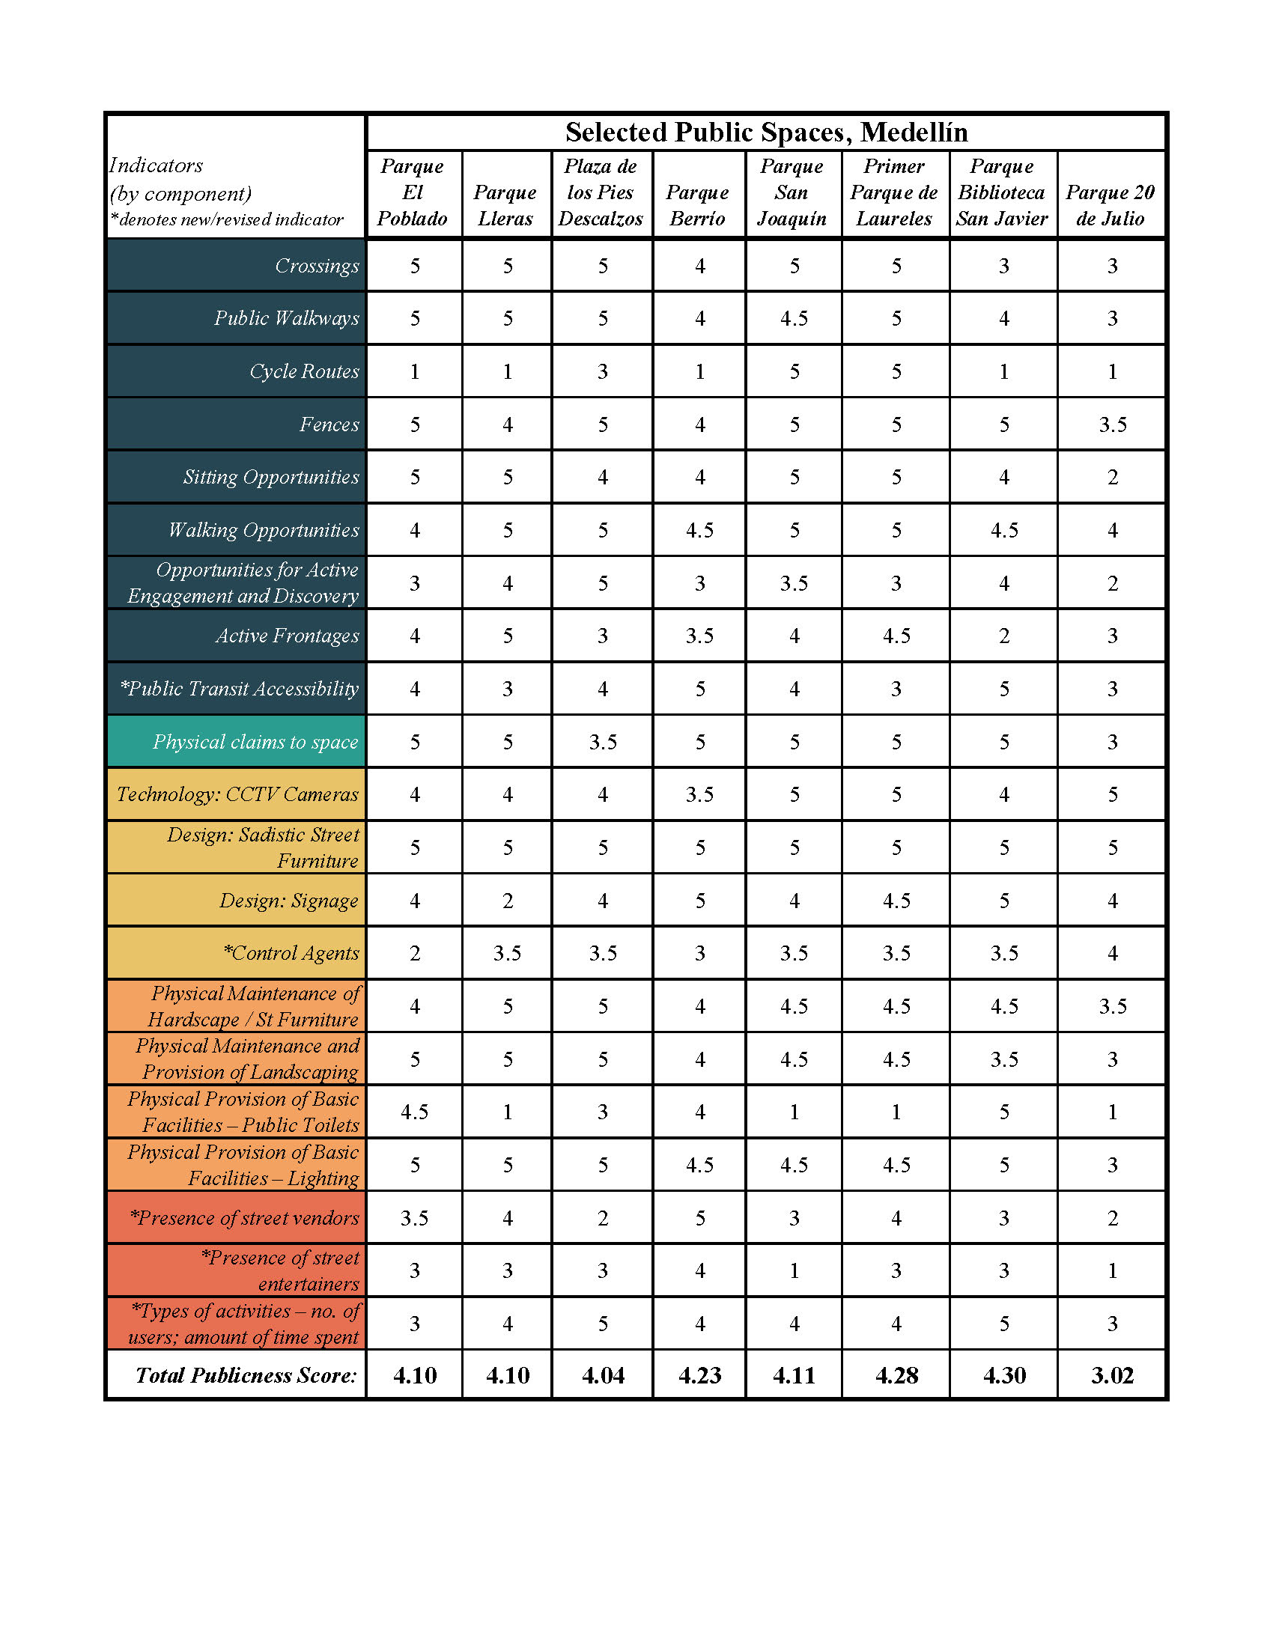
Appendix
